20XX-01-XXXX

Discrete Curvature Approach for Trajectory Generation

Author, co-author

Affiliation

**Abstract**

Technology has evolved up to the point where vehicle autonomy is becoming a possibility. Autonomous vehicles require a high degree of localization and use of external sensors for environment recognition. However, infrastructure technology is not at the same level as current vehicle innovations. This research proposes a method for creation, transmission, and guidance of a vehicle from purely infrastructure information. This paper is focused on a technique for generating a discrete curvature-dependent path from offline database information such as GPS or geographical scans. The technique is further developed with AASHTO guidelines to increase accuracy and comply with dynamic tire limits. Results showed that this method provides a reasonable guidance parameter for autonomous vehicles.

Keywords: Trajectory Generation, Path Generation, Curvature, AASHTO, V2I, Vehicle-to-Infrastructure

**Introduction**

The overall system consists of using Vehicle to Infrastructure (V2I) Communications to send the vehicle a path to follow any given curve. A controller needs to be developed to address the trajectory and modularity in any given sedan vehicle. This path is computed offline and stored in a transmitter that resides on infrastructures. This transmitter will send the desired path and a trajectory will be computed onboard. The transmission of the signal will be desired to be small as possible.

The following assumptions were considered:

* Vehicles contains enough technology to drive itself given a set amount of data (in this case, ideal heading angle, curvature)
* Method is not built considering collision avoidance, though it could be implemented
* Only sedan vehicles were studied, but can be extended to other vehicles
* Random animals and extreme accidents are ignored
* Anomalies in the road profile such as potholes are ignored
* Road is assumed to be in drivable conditions

The end goal of this project offers a backup system to detection sensors such as camera and lidar which will allow vehicles to travel under weather disruptions. To achieve this goal, the project was divided into three main parts. The first one is vehicle local trilateration, which establishes a vehicle position through transmission in between infrastructures and vehicles. The second part involves offline path generations and the minimization of data transmission of navigation data. The third part focuses on developing a controller to navigate with the road paths from the second part. For this paper, only the second part will be analyzed.

**Problem Statement**

The problem formulation involves generating an offline path that minimizes the data size needed to traverse a curved road.

**Trajectory Generation Background**

In motion planning, a path is defined a set of possible ways a vehicle is allowed to go from Point A to Point B. While trajectory is defined as the profile needed to go through that path given different constraints. For example, many trajectories can lie inside of a given path as shown in Figure 1. Given constraints can be in the form of differential constraints from equations of motion, geometrical constraints or dynamic constraints from vehicle limits.

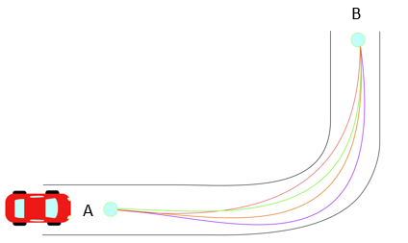

Figure 1 - Different Trajectories in a Given Path from Point A to Point B

In autonomous vehicles, many techniques have been used to generate trajectories traversing curves that satisfy a set of given constraints [1] [2] [3]. Most common techniques involve using Euler-Lagrange equations to obtain fifth degree polynomials along with differential constraints [4] [5]. Other techniques generate trajectories from clothoids, curvature polynomials, and piece-wise functions [6] [7] [8]. These methods often need non-holonomic constraints which are defined as constraints on higher order derivatives of the positions (i.e. velocity and acceleration).

From literature review, the following criteria was selected to generate a path that solves the problem statement. The path generated needs:

* To provide a smooth ride for the driver
* To be independent of road markings or current infrastructure signs
* To be general enough so that different trajectories are used in other vehicles
* To have the least amount of data transmitted as possible
* To be generated from any road type
* To be independent of information from camera sensors or lidar sensor

The techniques cited before [1-8] are able to satisfy some the criteria that is being stated above. However, to generate the least amount of data transmitted as possible, a set of additional parameters needed to be considered. These were used to compare methods of path generation and develop a proposed solution. These parameters include:

* Computation time offline and online
* Size of transmitted data online
* Length of road section needed
* Dynamic constraints such as maximum acceleration and velocity
* Geometric constraints such as curvature and road geometry

From comparing techniques, it was noted how most boundary value problems such as [4] [5] offer solutions of analytical higher order equations, while others contain non-closed forms [2]. Consequently, high computation costs are needed to calculate trajectories during onboard operations. Solutions compared include coordinate and curvature polynomials of high order. These type of polynomial solutions introduce rounding and truncation errors that typically occur in machine operations [9] [10]. In autonomous vehicle operations, both accuracy and speed are essential for optimum performance. As accuracy of polynomial approximations increases by extending the operations of polynomial coefficients, its speed of transmission decreases. Decreasing the amount of coefficients provide non-compliant solutions, and the sensitivity of the coefficients is affected as well. This makes accuracy and speed of transmission an inverse relationship which should not be allowed for this V2I technology.

In this project, it was determined that size of data should be minimized during transmission per length segment. Through this analysis, it was noted that conventional path generation techniques onboard vehicles do not offer a reliable solution for infrastructure data transmission.

**Problem Solution**

An approach was selected for a discrete solution based on offline road geometry generation. Focused on its minimum data transmission.

A set of unit vectors known as Normal-Tangential (N-T) Coordinates is used for the formulation of this path. N-T coordinates have been used extensively in works that define curvilinear motion of particles in space [11]. For this project, a 2D Euclidean space is selected in which N-T coordinates will be used to represent the motion of vehicle’s center of mass traversing a curve as shown in Figure 2.

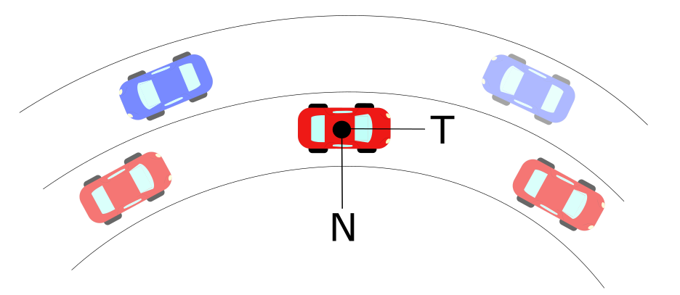

Figure 2 - Normal-Tangential Coordinates Example in Vehicle’s Center of Mass

As the vehicle goes through the curve, it is limited to constraints provided by road geometry and friction limits on the vehicle tires [12] [13]. These limits are related to the acceleration a vehicle goes under circular motion, which is denoted as:

$$a=\dot{v} T+{κv}^{2} N$$

Where:

a = Total Acceleration of Vehicle (m/s2)

v = Tangential Velocity of Vehicle (m/s)

$κ$ = Curvature at an Instantaneous Point (m-1)

N =Normal Unit Vector

T= Tangential Unit Vector

Curvature can be defined analytically, physically and geometrically. It measures how fast the tangential unit vector T changes with respect to an instantaneous point in the curve. The inverse of curvature is known as radius of curvature $ρ$ which indicates the radius of circumscribed circle at a point in a curve. Derivations for defining curvature are given in the Appendix [A.1], and have been extensively developed in other works [11] [12]. Curvature can be expressed in a vector form that has a direction in the Normal Unit Vector shown in Figure 2 . By definition of N-T coordinates, a vector perpendicular to the curvature direction will provide a velocity tangent vector approximation. This velocity vector provides a heading angle to the desired trajectory that is needed to follow a road path.

Typical highway roads are designed based on AASHTO guidelines to provide a natural, easy-to-follow path for drivers, such that the lateral force increases and decreases gradually as the vehicle enters and leaves a circular curve [16]. This leads to an approach of curvature generation based on AASHTO road geometry to obtain heading angles. To develop this, a geometric definition of radius of curvature is used to obtain both its magnitude and direction as shown in the Appendix [A.2] [17]. The radius of curvature is computed from discrete points that represent coordinates of a road. To obtain different approximations, different methods to coordinates were used. The first method involved a base model of the road based on AASHTO guidelines. The second method involved using Google Earth coordinates, and the third one involved GPS coordinate acquisitions.

**AASHTO Base Model**

This model consisted on strictly using AASHTO guidelines to design an ideal highway road for a vehicle traversing at constant 60 mph. The curve consisted of 5 different sections that can be classified as: straight section, entrance transition, constant radius curve, exit transition and straight section. Applying the discrete geometric approach to this curve [A.2], curvature vectors were plotted with respect to the road segments as shown in Figure 3. The curvature magnitude was plotted with respect to road segments to obtain a base curvature profile as shown in Figure 4.



Figure 3 - AASHTO Base Model: Road with Curvature Vectors



Figure 4 - AASHTO Base Model: Curvature κ vs. Cumulative Curve Length

With the curvature profile established, two different approaches were used to confirm the heading angle approximation. One method involved obtaining the heading angle from trigonometric functions on the curvature vectors and add an orthogonal phase shift. The second method involved numerical integration of the curvature data to obtain a heading angle. The proof of the method is shown in [Appendix] and both methods are shown in Figure 5 and Figure 6. Results on heading angles with respect to road segments are shown in Figure 7.These resulting angles were used as input data on a controller developed in [Michael].



Figure 5 - AASHTO Base Model: Orthogonal Phase Shift Approach



Figure 6 - AASHTO Base Model: Numerical Integration Approach



Figure 7 - AASHTO Base Model: Road with Velocity Vectors

**Google Earth Model**

This model is based off a selection of points in Google Earth that represent a highway road with design speed of 60 mph. The points were picked as close as possible to resemble the road centerline of the highway. The road profile and resulting vectors from applying the aforementioned discrete geometry approach are shown in Figure 8. It is noticeable how the vector directions choose arbitrary tangent directions when the curve approaches a straight line section. The curvature magnitude with respect to length was also plotted in Figure 9 and it was observed that magnitude deviations increased considerably compared to the ideal AASHTO model.



Figure 8 - Google Earth Model: Road with Velocity Vectors



Figure 9 - Google Earth Model: Curvature κ vs. Cumulative Curve Length

The method was not efficient in calculating curvature magnitudes, but the direction of the heading angle obtained from the orthogonal phase shift still provided comparable results to those found by calculating with AASHTO as shown in Figure 10. Similarly, the resulting velocity vectors to guide the vehicle provide a suitable heading direction as shown in Figure 11. These resulting angles were used as input data on a controller developed in [Michael] to study the efficiency of navigating with this input information.



Figure 10 - Google Earth Model: Orthogonal Phase Shift Approach



Figure 11 - Google Earth Model: Road with Velocity Vectors

Appendix

A.1 – *Heading Angle Integration Formulation*

The arc-length s of a curve is defined as the length traveled by a certain amount of degrees $θ$ along a constant radius r. If s is sufficiently small, a triangle can be formed in between these three parameters, which are related through geometry:

$$\sin{θ}=\frac{s}{r}$$

Defining r as the radius of curvature at the specific arc-length and letting $r=ρ$.

$$\sin{θ}=\frac{s}{ρ}$$

By the previous assumption of small angles: $\sin{θ}=θ$

Which leads to

$θ=\frac{s}{ρ}$ (1)

Let the Curvature $κ$ be denoted as $ρ=1/κ$

Substituting this definition into equation (1)

$$θ=κs$$

Assuming a differential section for $θ$ and $s$. Rearranging for $κ$:

$$κ=\frac{dθ}{ds}$$

By separation of variables and integration

$$\int{κds}= \int{dθ}$$

Which concludes that the angle of orientation as a function of arc-length s can be found through numerical integration of the curvature as:

$$θ\left(s\right)= \int{κ\left(s\right)ds}$$

To obtain the curvature, let a scalene triangle with corners A, B, C have a circumscribed circle of radius r.

A.2 – *Discrete Curvature Formulation*

Let a scalene triangle with corners A, B, C have a circumscribed circle of radius R in Euclidean 2D space as shown in Figure.

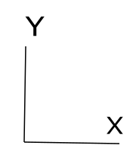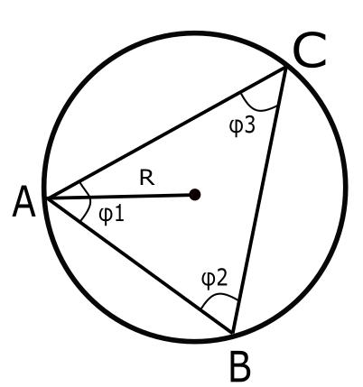

Circumscribed Circle in Scalene Triangle

If we let a vector D be the cross product in between the vectors AB and AC, the direction will be pointing out normal to the plane defined by the intersection of AB and AC. By definition of the magnitude for cross product:

$$\left\|D\right\|= \left\|AB ×AC\right\|= \left\|AB\right\| \left\|AC\right\| \sin{ϕ_{1}}$$

Let a vector E be the cross product of D with the vector AB, defining this new vector in the direction of $e_{1}$ as shown in Figure. Let the magnitude of vector E be defined as:

$$\left\|E\right\|=\left\|D×AB\right\|={\left\|AB\right\|}^{2}\left\|AC\right\| \sin{ϕ_{1}}$$

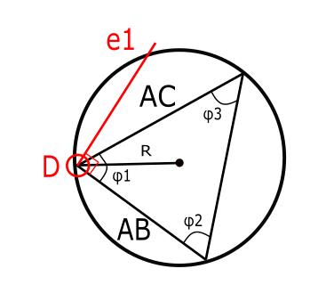

Similarly, let a vector F be the cross product of D with the vector AC, defining this new vector in the direction of $e_{2}$. Let the magnitude of vector E be defined as:

$$\left\|F\right\|=\left\|D×AC\right\|=\left\|AB\right\|{\left\|AC\right\|}^{2} \sin{ϕ_{1}}$$

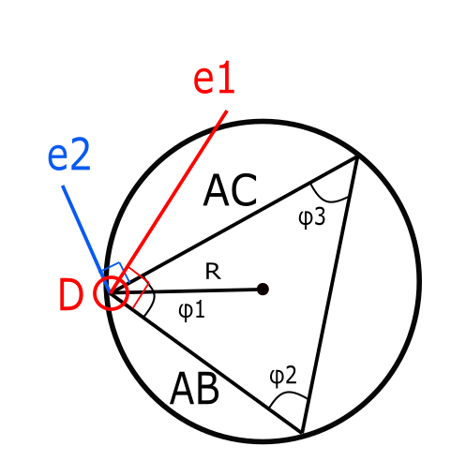

The unit vectors of $e_{1}$ and $e_{2}$ are defined by the following:

$$e_{1}=\frac{E}{{\left\|AB\right\|}^{2}\left\|AC\right\|\sin{ϕ_{1}}}$$

$$e_{2}=\frac{F}{\left\|AB\right\|{\left\|AC\right\|}^{2}\sin{ϕ_{1}}}$$

By definition, the midsection of any triangle’s side intersects with each other at a point P as shown in Figure. These intersecting lines denote two triangles with the same angle $ϕ_{1}$ in between the unit vectors and their corresponding midsections as shown below.

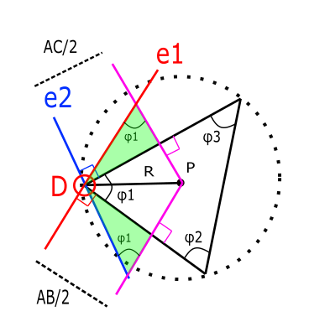

From these triangles, it is possible to break the vector DP into components along unit vectors $e_{1}$ and $e_{2}$ to obtain a new definition of DP in a different set of coordinates as follows:

$$DP_{1}=\frac{AC}{2\sin{ϕ_{1}}} e_{1}=\frac{E}{2{\left\|AB\right\|}^{2}\sin^{2}{ϕ_{1}}}$$

$$DP_{2}=\frac{-AB}{2\sin{ϕ_{1}}} e_{2}=\frac{-F}{2{\left\|AC\right\|}^{2}\sin^{2}{ϕ_{1}}}$$

From our previous definition of the vector D, it is possible to simplify further:

$$DP_{1}=\frac{{\left\|AC\right\|}^{2}E}{2{\left\|D\right\|}^{2}}$$

$$DP_{2}=\frac{{-\left\|AB\right\|}^{2}F}{2{\left\|D\right\|}^{2}}$$

With these components, it is possible to obtain the magnitude as follows:

$$DP= \frac{{\left\|AC\right\|}^{2}E}{2{\left\|D\right\|}^{2}}- \frac{{\left\|AB\right\|}^{2}F}{2{\left\|D\right\|}^{2}}$$

$$R= \frac{{\left\|AC\right\|}^{2}E-{\left\|AB\right\|}^{2}F}{2{\left\|D\right\|}^{2}}$$

Using previous definitions of E and F:

$$R= \frac{{\left\|AC\right\|}^{2}\left\|D×AB\right\|-{\left\|AB\right\|}^{2}\left\|D×AC\right\|}{2{\left\|D\right\|}^{2}}$$

Using previous definition of D, it is possible to obtain the radius of the prescribed circle in terms of only the difference in between points A, B and C.

$$R= \frac{{\left\|AC\right\|}^{2}\left\|(AB×AC)×AB\right\|-{\left\|AB\right\|}^{2}\left\|(AB×AC)×AC\right\|}{2{\left\|(AB×AC)\right\|}^{2}}$$

Using the previous definition, it is possible to apply the formulation of R to differentially small arc segments as it is shown below.

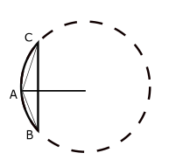

Scalene Triangle in Arc-Segment

By definition, the radius of this circumscribed circle is called radius of curvature, and its inverse is known as curvature denoted as:

$$κ=\frac{1}{R}$$

Through this definition it is possible to extend the application of this discrete radius of curvature and applying it to long-discrete arc segments as shown in Figure:

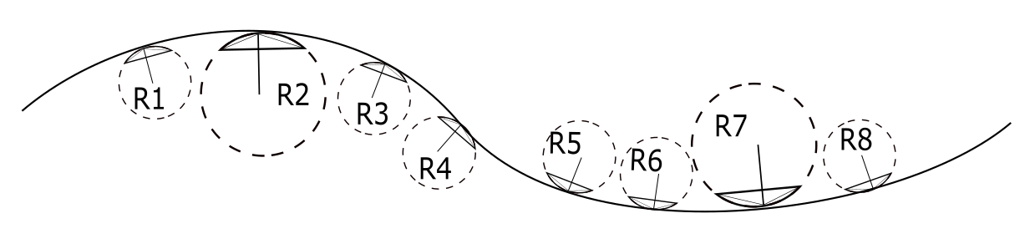

Road Section with Discrete Sections

References

1. M. Werling, J. Ziegler, K. Soren, and S. Thrun. *Optimal Trajectory Generation for Dynamic Street Scenarios in a Frenet Frame*, 2010
2. A. Kelly, B. Nagy, *Reactive Nonholonomic Trajectory Generation via Parametric Optimal Control*, 2003
3. Y. Sun, Z. Zhan, Y. Fang, L. Zheng, L. Wang, G. Guo, *A Dynamic Local Trajectory Planning and Tracking Method for UGV Based on Optimal Algorithm,* 2019
4. A. Takahashi, T. Hongo, Y. Ninomiya, G. Sugimoto, *Local Path Planning and Motion Control for AGV in Positioning*, 1989
5. A. Piazzi, C. Guarino lo Bianco, *Quintic G2-Splines for Trajectory Planning of Autonomous Vehicles,* 2000
6. D. Wilde, *Computing Clothoid-Arc Segments for Trajectory Generation*, 2009
7. H. Delingette, M. Hebert, K. Ikeuchi, *Trajectory Generation with Curvature Constraint based on Energy Minimization*, 1991
8. L. J. van Vliet, P. W. Verbeek, *Curvature and Bending Energy in Digitized 2D and 3D Images*, 1993
9. P. Guillaume, J. Schoukens, R. Pintelon*, Sensitivity of Roots to Errors in the Coefficient of Polynomials Obtained by Frequency –Domain Estimation Methods*, 1989
10. K. E. Atkinson, *An Introduction to Numerical Analysis*, 1989
11. O. M. O’Reilly, *Engineering Dynamics A Primer*, 2010
12. A.N. Pressley, *Elementary Differential Geometry*, 2010
13. H. B. Pacejka, *Tyre and Vehicle Dynamics*, 2006
14. T. D. Gillespie, *Fundamentals of Vehicle Dynamics*, 1992
15. M. P. do Carmo, *Differential Geometry of Curves and Surfaces*, 1976
16. AASHTO, *A Policy on Geometric Design of Highways and Streets*, 2011
17. A. Mjaavatten, *Curvature of a Discrete Curve in 3D Space*, 2018
18. M. Duhn, G. Parikh, J. Hourdos, *I-94 Connected Vehicles Testbed Operations and Maintenance*, 2019
19. Druta, A. S. Alden, *Implementation and Evaluation of a Buried Cable Animal Detection System and Deer Warning Sign*, 2019
20. SAE International, *J3016-Taxonomy and Definitions for Terms Related to Driving Automation Systems for On-Road Motor Vehicles,* 2018
21. William J. Hughes Technical Center, *Global Positioning System (GPS) Standard Positioning Service (SPS) Performance Analysis Report*, 2017
22. S. Heinrich, *Planning Universal On-Road Driving Strategies for Automated Vehicles,* 2018